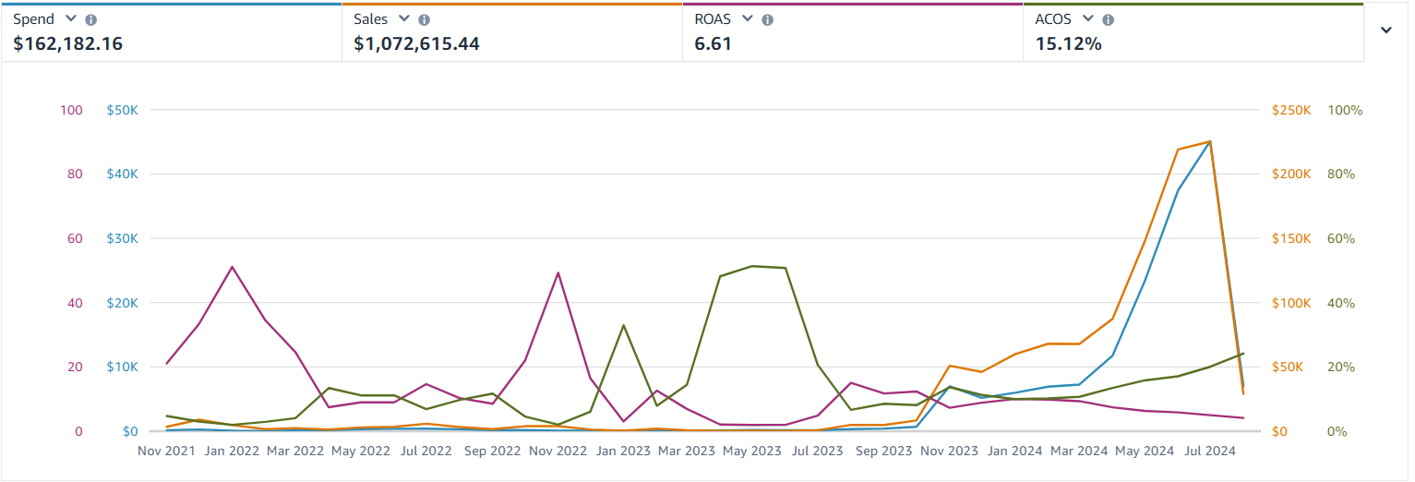
🔥 Case Study: Scaling Amazon Revenue Beyond $1M with High-Efficiency PPC Strategy 🔥

🛑 The Situation
Zulay Kitchen, a well-known mid-size brand in the Home & Kitchen category, was already generating consistent sales on Amazon. However, their advertising performance had not yet reached its full potential.

While revenue was growing, the structure behind the campaigns lacked efficiency and long-term scalability.

💡 The Challenge
After auditing the account, key issues were identified:

• High ad spend without optimal efficiency
• Lack of advanced campaign segmentation
• Missed scaling opportunities on high-performing keywords
• Inconsistent growth patterns over time

👉 The brand was performing… but not maximizing its potential.

⚙️ Our Approach

🎯 Advanced PPC Restructuring
We rebuilt the campaign structure to clearly separate scaling campaigns from testing campaigns, allowing better control over performance.

📊 Data-Driven Scaling
We focused heavily on search term data to identify winning keywords and gradually increased bids only where profitability was proven.

💰 Budget Allocation Strategy
Instead of increasing spend across the board, we concentrated budget on high-return campaigns and eliminated inefficiencies.

🛒 Conversion Alignment
We ensured that traffic quality matched listing performance, improving conversion alongside traffic growth.

⚡ The Results

• $1,072,615.44 in total sales 📊
• 6.61 ROAS 🚀
• 15.12% ACOS 📉
• $162,182.16 ad spend efficiently utilized 💰

👉 A clear shift from steady growth to optimized, scalable performance.

🧠 Key Insight

• Scaling works best when backed by data
• Efficiency is more powerful than aggressive spending
• Structured campaigns unlock higher returns

💬 Outcome

Zulay Kitchen achieved:

• Strong revenue growth beyond $1M
• Improved ad efficiency
• Scalable campaign structure

🌟 Ready to Scale Like This?

If your brand is already generating sales but not scaling efficiently, the next level comes from strategy, not just spend.

Let’s build a system that scales.

