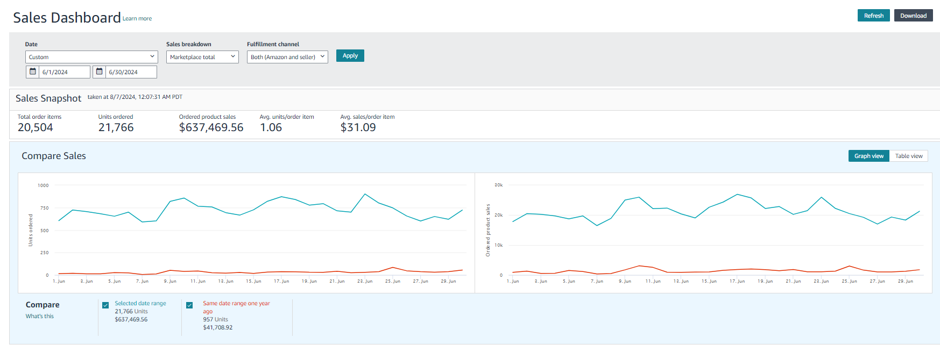
🔥 Case Study: Driving Consistent Revenue Growth for TruSkin Through Strategic Amazon Optimization 🔥

🛑 The Situation
TruSkin, a well-recognized skincare brand on Amazon, was already generating steady sales. However, the growth was not consistent and lacked scalability.

While the brand had strong demand, the account performance was not fully optimized to maximize revenue potential.

💡 The Challenge
After reviewing the account, we identified:

• Inconsistent daily sales trends
• Underutilized keyword opportunities
• Lack of structured campaign scaling
• Limited alignment between traffic and conversion

👉 The brand had strong market presence, but needed a refined system to scale efficiently.

⚙️ Our Approach

🎯 Campaign Structure Optimization
We refined campaign segmentation to clearly separate testing, scaling, and branded campaigns.

📊 Data-Driven Decisions
We analyzed performance data to identify high-converting keywords and gradually increased bids on profitable segments.

💰 Smart Budget Allocation
We shifted budget toward top-performing campaigns while minimizing spend on underperforming areas.

🛒 Conversion Support
We ensured listing alignment with traffic quality to improve conversion rates and maximize returns.

⚡ The Results

• $637,469.56 in total sales 📊
• 21,766 units sold 📦
• $31.09 average order value 💰
• Strong, consistent sales performance across the month 📈

👉 From fluctuating performance to stable, predictable growth.

🧠 Key Insight

• Consistency is key for long-term scaling
• Data-driven scaling outperforms aggressive spending
• Structured campaigns create predictable revenue

💬 Outcome

TruSkin achieved:

• More stable daily sales
• Improved campaign control
• Stronger foundation for long-term scaling

🌟 Ready to Build Consistent Growth?

If your Amazon sales are inconsistent, the solution lies in structure, data, and strategy—not just increasing spend.

Let’s build a system that delivers consistent results.

