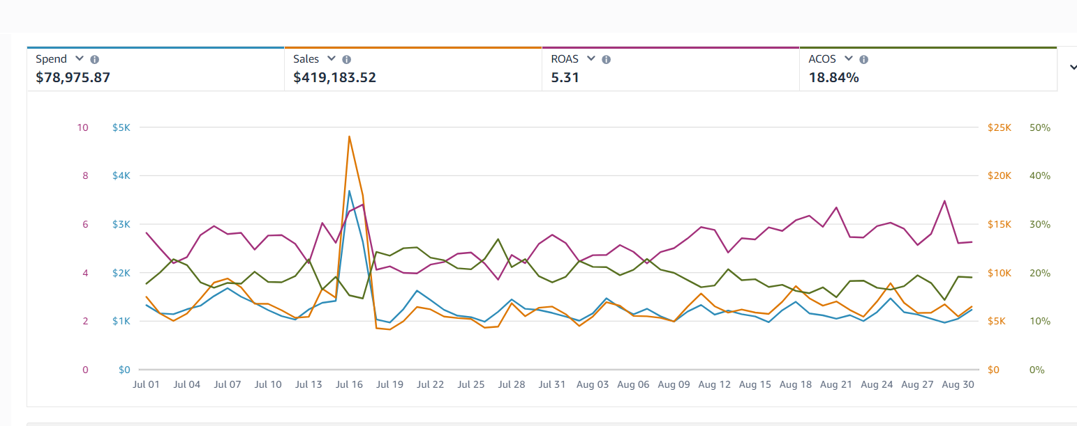
🔥 Case Study: Scaling Amazon Performance for MoonMaid Botanicals with Smarter PPC Optimization 🔥

🛑 The Situation
MoonMaid Botanicals, a growing brand in the health & wellness space, had strong potential on Amazon. However, despite consistent advertising efforts, their performance lacked efficiency and scalability.

Sales were being generated, but the return on ad spend and overall structure needed improvement.

💡 The Challenge
After analyzing the account, we identified key gaps:

• High ad spend without optimal efficiency
• Campaign structure lacking clarity
• Missed opportunities in high-intent keyword targeting
• Inconsistent performance across campaigns

👉 The brand had demand, but performance was not fully optimized.

⚙️ Our Approach
We focused on refining and structuring the account rather than making aggressive changes:

🎯 PPC Restructuring
We reorganized campaigns to improve segmentation, targeting, and bid control. This allowed better clarity on what was performing.

📊 Continuous Optimization
We analyzed search terms, adjusted bids gradually, and eliminated underperforming areas while scaling winning keywords.

💰 Budget Efficiency
We redirected spend toward high-performing campaigns and reduced inefficiencies to improve overall return.

🛒 Conversion Support
We aligned traffic with better listing performance to ensure improved conversion from existing visitors.

⚡ The Results (60 Days)

• $419,183.52 in total sales 📊
• 5.31 ROAS 🚀
• 18.84% ACOS 📉
• $78,975.87 ad spend efficiently utilized 💰

👉 The results reflected structured and sustainable growth rather than short-term spikes.

🧠 Key Insight
The improvement came from:

• Consistent optimization
• Better campaign structure
• Smarter budget allocation

👉 Not from increasing spend, but from improving efficiency.

💬 Outcome
MoonMaid Botanicals achieved:

• More stable performance
• Better return on ad spend
• Stronger positioning for future scaling

🌟 Ready to Scale Your Amazon Brand?
If your campaigns are running but not delivering the expected results, the solution lies in strategy and structure.

Let’s build a system that works.

