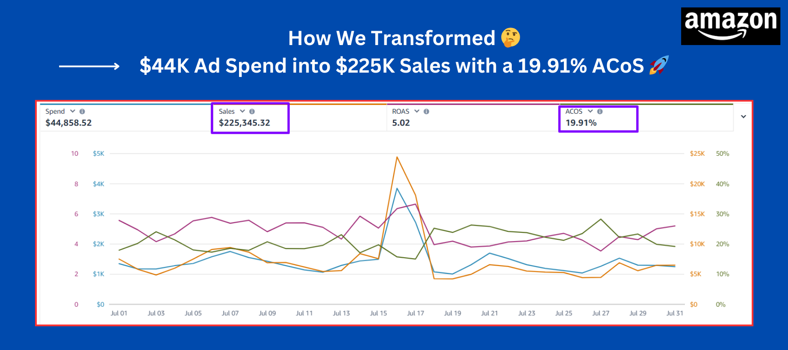
🔥 Case Study: Turning $44K Ad Spend into $225K Sales with Strategic Amazon PPC Optimization 🔥

🛑 The Situation
This Amazon brand was actively investing in ads and generating traffic, but the performance was not as efficient as it could be.

Despite consistent spend, the results lacked scalability and profitability.

💡 The Challenge
After reviewing the account, we identified:

• High ad spend with room for better efficiency
• Campaign structure not fully optimized
• Missed opportunities in high-intent keyword targeting
• Inconsistent performance across campaigns

👉 The brand had momentum, but lacked a structured system to scale profitably.

⚙️ Our Approach

🎯 PPC Restructuring
We reorganized campaigns to separate high-performing and low-performing segments, improving targeting and bid control.

📊 Continuous Optimization
We monitored search terms, adjusted bids gradually, eliminated waste, and scaled converting keywords.

💰 Budget Efficiency
We redirected budget toward top-performing campaigns instead of increasing spend blindly.

🛒 Conversion Alignment
We ensured listing and traffic alignment to improve conversion rates from existing visitors.

⚡ The Results (30 Days)

• $225,345.32 in total sales 📊
• 5.02 ROAS 🚀
• 19.91% ACOS 📉
• $44,858.52 ad spend efficiently utilized 💰

👉 Strong improvement driven by structure, not shortcuts.

🧠 Key Insight

• Consistency beats quick fixes
• Structure drives performance
• Efficiency enables scaling

💬 Outcome

The brand achieved:

• Improved profitability
• Better campaign control
• Stronger foundation for scaling

🌟 Ready to Scale Your Amazon Brand?

If your ads are running but not delivering expected results, the issue is not always the budget — it’s the strategy behind it.

Let’s build a system that works.

