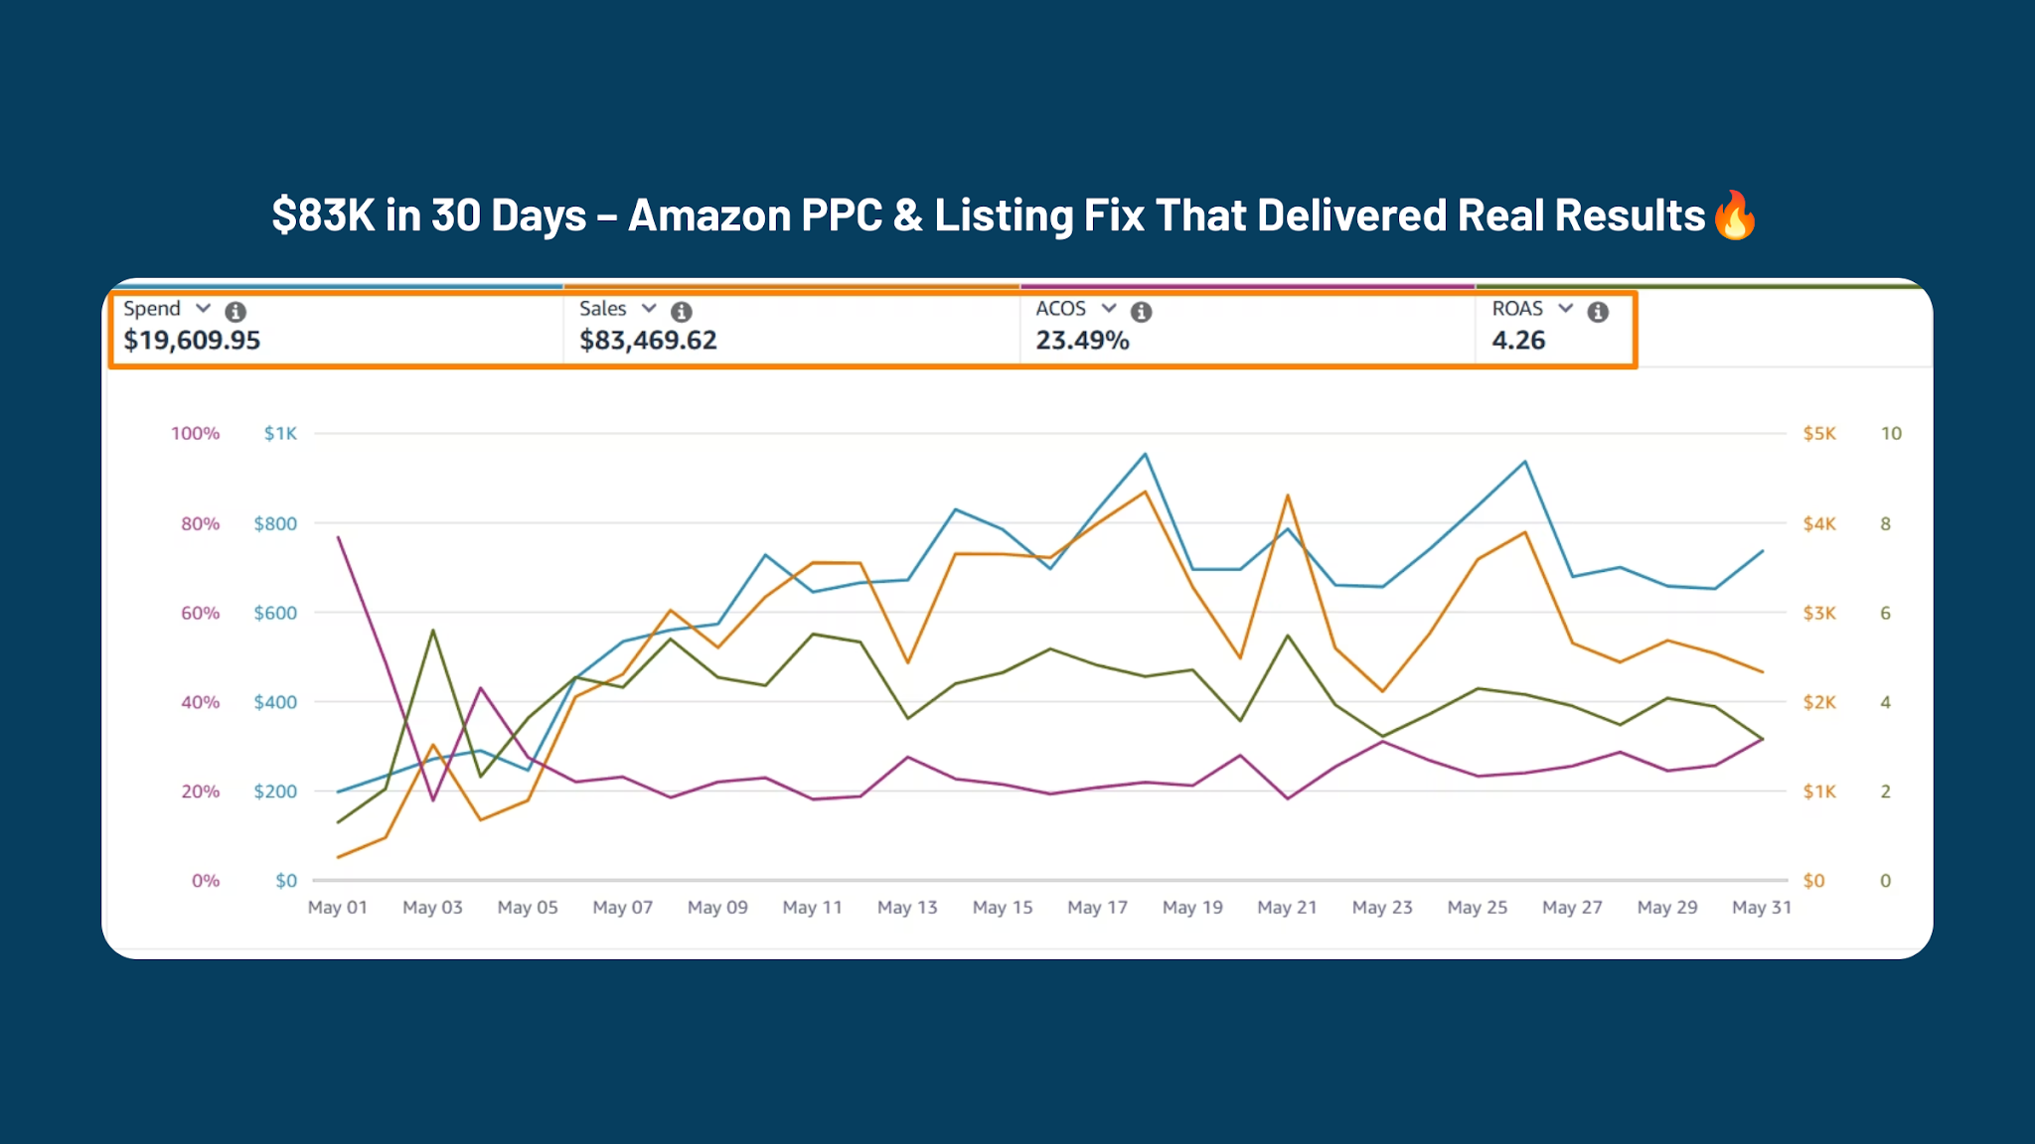
🔥 Case Study: Improving Amazon Performance for Brandt Beef with Smarter PPC & Listing Optimization 🔥

🛑 The Situation
Brandt Beef, a well-established premium meat brand, was already generating traction on Amazon. However, despite consistent ad spend and traffic, the results were not as efficient or scalable as expected.

Sales were coming in, but there was a clear gap between effort and performance.

💡 The Challenge
After auditing the account, we identified key issues:

• Ad spend was not being utilized efficiently
• Campaign structure lacked proper segmentation
• High-intent keywords were under-leveraged
• Listing had room for better conversion

👉 The brand had demand, but the system wasn’t built to capture it effectively.

⚙️ Our Approach
Instead of making aggressive changes, we focused on structured and data-driven improvements:

🎯 Campaign Restructuring
We reorganized campaigns to separate high and low performers, improving targeting and bid control. This allowed better visibility into what was working.

📊 Continuous Optimization
We monitored search terms, adjusted bids gradually, eliminated waste, and scaled winning keywords. Small, consistent improvements led to stronger performance.

🛒 Listing Optimization
We refined the listing to improve clarity, positioning, and customer decision-making—ensuring traffic converted more effectively.

💰 Budget Efficiency
Rather than increasing spend, we redirected budget toward high-performing campaigns and reduced inefficiencies.

⚡ The Results (30 Days)
After 30 days of optimization, the account showed measurable improvement:

• $83,469.62 in total sales 📊
• 4.26 ROAS 🚀
• 23.49% ACOS 📉
• $19,609.95 ad spend efficiently utilized 💰

👉 Not overnight success, but controlled and sustainable growth.

🧠 Key Insight
There was no “hack” behind these results.

👉 It was achieved through:
• Consistent optimization
• Clear campaign structure
• Data-driven decisions

💬 Outcome
Brandt Beef’s Amazon performance became:

• More stable
• More predictable
• More efficient

👉 Creating a strong foundation for future scaling.

🌟 Ready to Improve Your Amazon Performance?
If your ads are running but not delivering expected results, it’s time to fix the structure—not just increase the spend.
Let’s build a system that works.

